Supervisor Compliance Report
In Avatar LIVE browse for report: Avatar PM / Reports
The ‘Supervisor Compliance Report’ shows summary view of the clients currently in practitioner’s caseload and the list of assessments required to be in compliance.
Parameters:
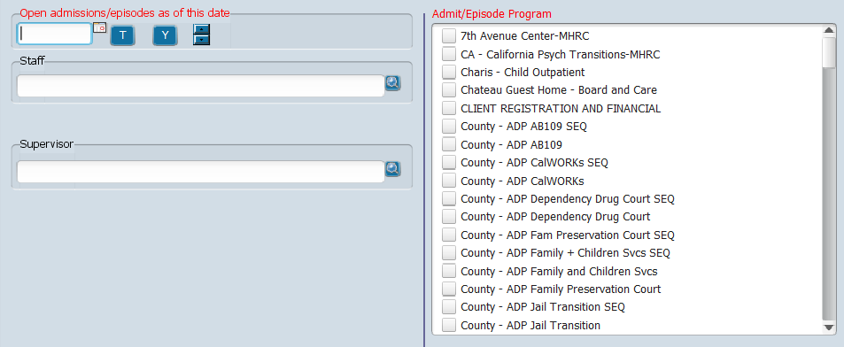
Open admissions/episodes as of this date: Select date that is greater than (or equal) to admission date and less than (or equal) to discharge date. If admission has no discharge date it will show as well.
Admit/Episode Program: Select from list of Admission programs.
Staff: Select a Practitioner to show clients he or she is assigned (as defined in Caseload Assignment form)
Supervisor: Select Supervisor to show clients assigned to each of the Practitioners
Note: Staff or Supervisor is required.

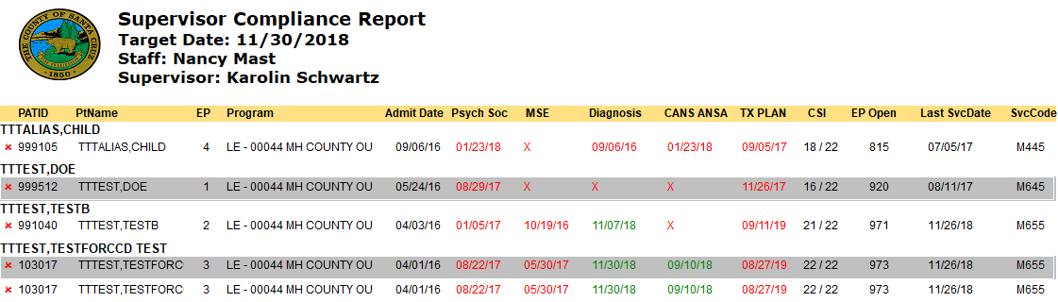
Depending on the Admit/Episode program selected, the report will display appropriate column headers.
For Mental Health Admit/Episode programs, the following assessments are required: Psychosocial Assessment, Mental Status Assessment, Diagnosis, CANS ANSA, Treatment Plan, and CSI information.

For SUD Admit/Episode programs, the following assessments are required: Diagnosis, Adult or Adolescent ALOC Assessment, ASAM Reassessment, Treatment Plan and CalOMS information.
Legend:
X means assessment was not found and is required
Date in red means either assessment is in Draft or needs an update

Definitions of a compliant Mental Health episode:
- Psychosocial Assessment must be less than 1 year old and in Final status
- Mental Status Assessment must be less than 1 year old and in Final status
- Diagnosis must be less than 1 year old
- CANS ANSA must be less than 6 months old and in Final status
- Treatment Plan must be less than 365 days old and in Final status
- CSI information must be all complete

Definitions of a compliant SUD episode:
- Diagnosis must be less than 1 year old
- Adult or Adolescent ALOC Assessment must be available
- ASAM Reassessment must be available and in Final status
- Treatment Plan must be less than 75 days old and in Final status
- CalOMS information must be available

